**Use Watson Discovery News to analyze cryptocurrency sentiment**

In this example, we will use Watson Discovery News in order to query articles written about Bitcoin and visualize the sentiment of the articles. This should act as a baseline for integrating Watson Discovery into your own application. The use cases are endless, with Watson Discovery, and especially the "news" collection, you can harness the power of advanced queries in order to gain many insights.

[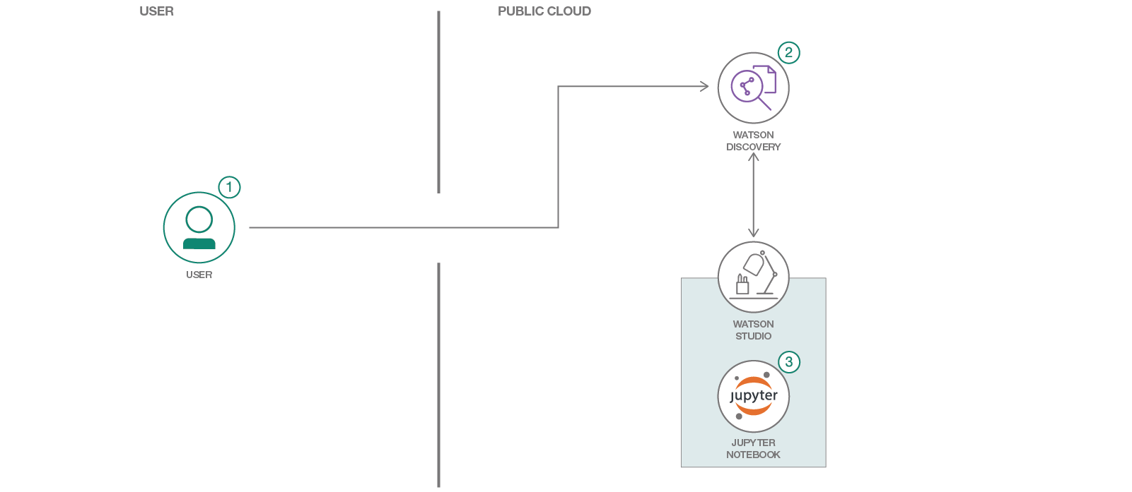](https://github.com/IBM/crypto-discovery-news-sentiment-analysis/blob/master/doc/source/images/architecture.png)

1. **Flow**
2. User creates an instance of Watson Discovery.
3. User run the provided Jupyter notebook with Watson Studio.
4. The Jupyter notebook leverages Watson Discovery News to visualize data sentiment and date.
5. **Included Components**

* [Watson Studio](https://dataplatform.cloud.ibm.com/)
* [Watson Discovery](https://www.ibm.com/watson/services/discovery/)

1. **Featured Technologies**

* [Jupyter Notebooks](http://jupyter.org/)
* [Matplotlib](https://matplotlib.org/)

1. **Steps**

**Sign up for Watson Studio**

Sign up for IBM's [Watson Studio](https://dataplatform.cloud.ibm.com). After signing in, create a new, **basic** project – give it a name, and create a new object storage service if prompted (the **lite** option will work fine).

**Allocate Discovery service**

Head over to [IBM Cloud](http://bluemix.net/), if prompted, login with the same credentials as above. From the dashboard, click **Create Resource** and search for "*Discovery*" in the catalog. Click on the Discovery card, and click **Create**.

**Create Notebook**

From Watson Studio, navigate to the project you created previously.

1. In the Assets tab, select the Create notebook option.
2. Select the From URL tab.
3. Enter a name for the notebook.
4. Optionally, enter a description for the notebook.
5. Enter this Notebook URL: <https://raw.githubusercontent.com/IBM/crypto-discovery-news-sentiment-analysis/master/notebooks/crypto-analysis.ipynb>

**Run the notebook**

Once the notebook has been created, navigate to the cell with Watson Discovery credentials and enter your own. To find your credentials, navigate to your Discovery service, click on the menu item labeled *Credentials*, generate a new set if none exists yet. Now, you can run the notebook and analyze the results.

**Example output**

See [examples/example_notebook.ipynb](https://github.com/IBM/crypto-discovery-news-sentiment-analysis/blob/master/examples/example_notebook.ipynb) for a full run of the notebook with output.

Below is a snapshot of the type of analysis performed, showing both sentiment and date for cryptocurrencies.

[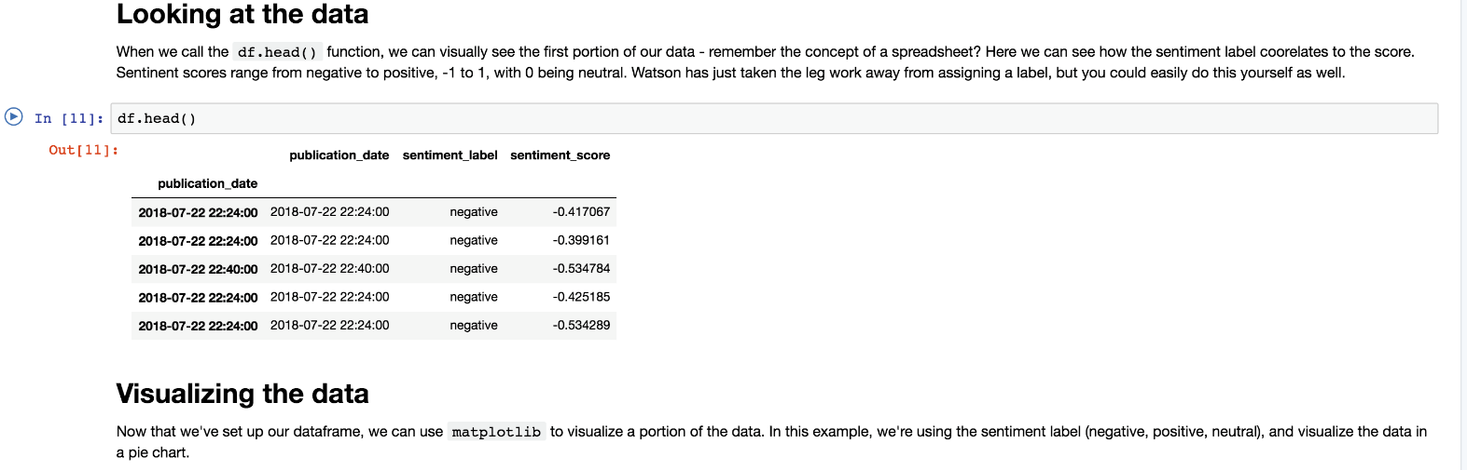](https://github.com/IBM/crypto-discovery-news-sentiment-analysis/blob/master/doc/source/images/example_output.png)

1. **Learn more**

* **Data Analytics Code Patterns**: Enjoyed this Code Pattern? Check out our other [Data Analytics Code Patterns](https://developer.ibm.com/code/technologies/data-science/)
* **With Watson**: Want to take your Watson app to the next level? Looking to utilize Watson Brand assets? [Join the With Watson program](https://www.ibm.com/watson/with-watson/) to leverage exclusive brand, marketing, and tech resources to amplify and accelerate your Watson embedded commercial solution.
* **Watson Studio**: Master the art of data science with IBM's [Watson Studio](https://dataplatform.ibm.com/)

1. **Links**

* Check out the [blog post](https://medium.com/@SamuelCouch/visualizing-sentiment-in-the-news-89f40e8fcc21)!

1. **License**

This code pattern is licensed under the Apache Software License, Version 2. Separate third party code objects invoked within this code pattern are licensed by their respective providers pursuant to their own separate licenses. Contributions are subject to the Developer [Certificate of Origin, Version 1.1 (DCO)] (<https://developercertificate.org/>) and the [Apache Software License, Version 2] (<http://www.apache.org/licenses/LICENSE-2.0.txt>).

ASL FAQ link: <http://www.apache.org/foundation/license-faq.html#WhatDoesItMEAN>



© Copyright IBM Corporation 2018.

The information contained in these materials is provided for informational purposes only and is provided AS IS without warranty of any kind, express or implied. IBM shall not be responsible for any damages arising out of the use of, or otherwise related to, these materials. Nothing contained in these materials is intended to, nor shall have the effect of, creating any warranties or representations from IBM or its suppliers or licensors, or altering the terms and conditions of the applicable license agreement governing the use of IBM software. References in these materials to IBM products, programs, or services do not imply that they will be available in all countries in which IBM operates. This information is based on current IBM product plans and strategy, which are subject to change by IBM without notice. Product release dates and/or capabilities referenced in these materials may change at any time at IBM’s sole discretion based on market opportunities or other factors and are not intended to be a commitment to future product or feature availability in any way.

IBM, the IBM logo and ibm.com are trademarks of International Business Machines Corp., registered in many jurisdictions worldwide. Other product and service names might be trademarks of IBM or other companies. A current list of IBM trademarks is available on the Web at “Copyright and trademark information” at www.ibm.com/legal/copytrade.shtml.

Please Recycle